Lecture -247 Content Delivery Networks (CDNs) introduction

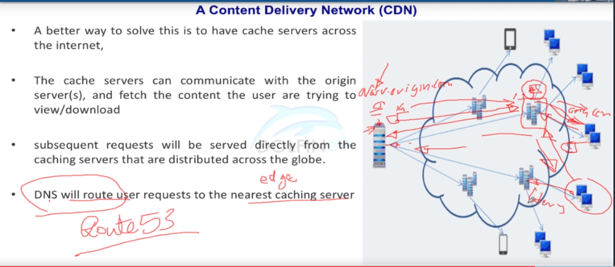

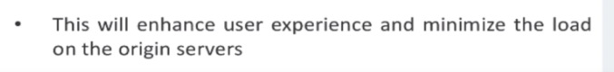

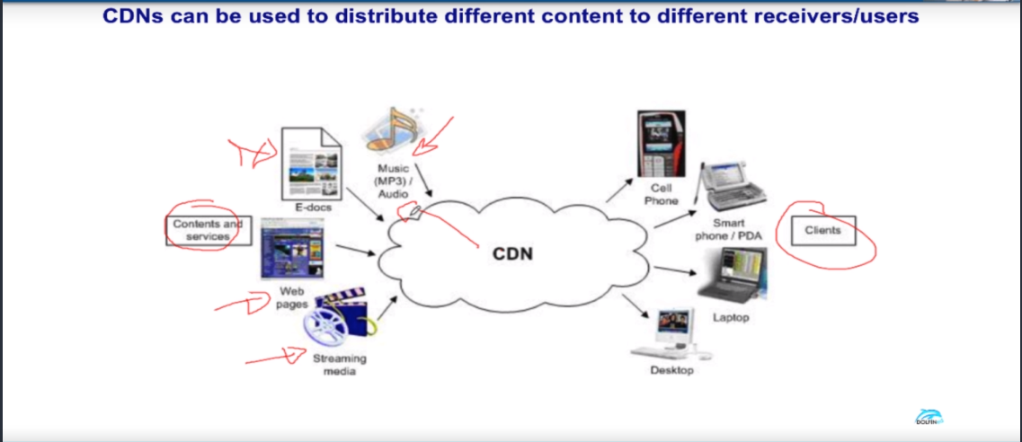

Lecture-249 CloudFront - Introduction

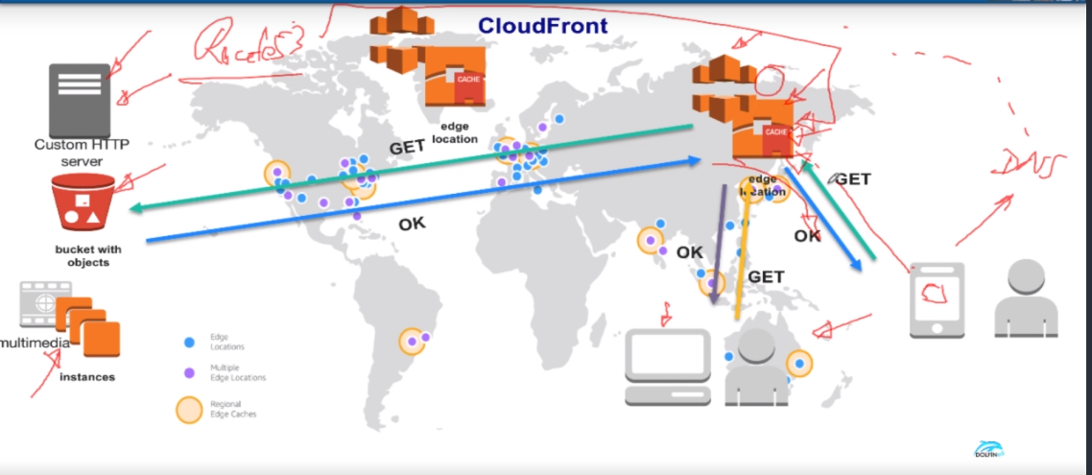

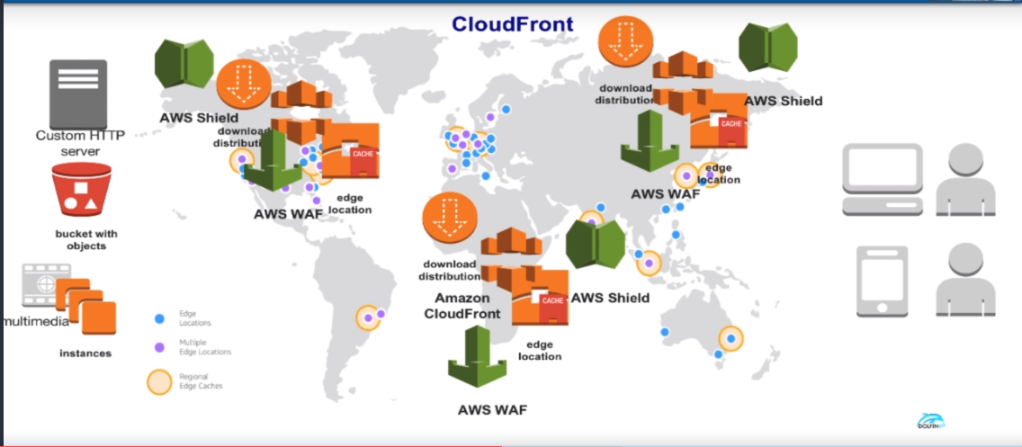

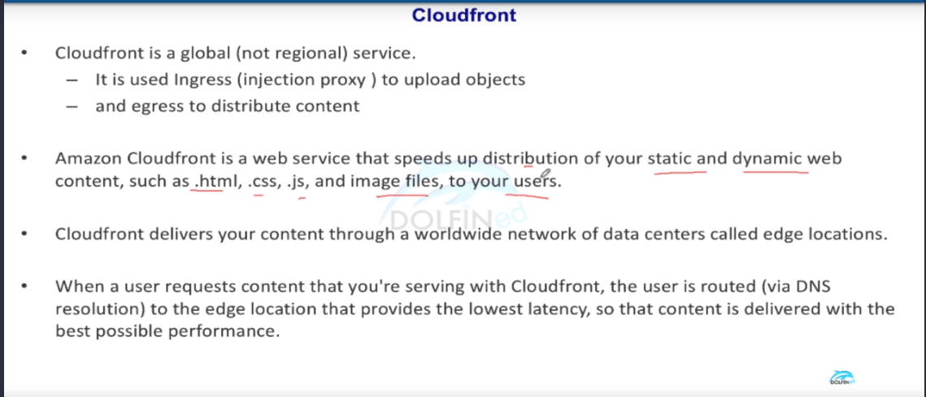

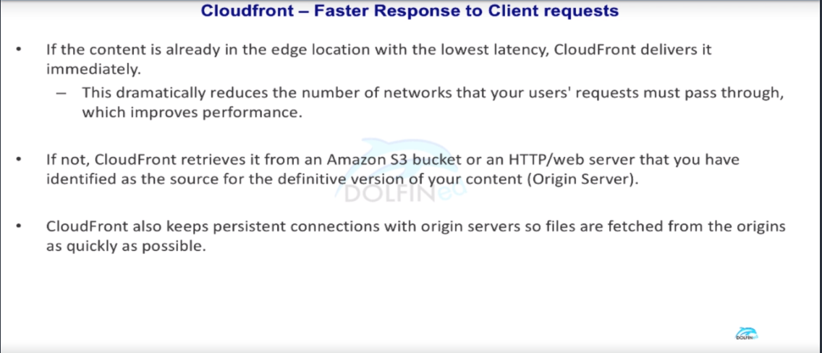

In the above pic 3rd point depicts that edge location will keep the session alive with (TCP) origin servers. So, whenever a new data is required it would help in fetching quickly. So, whenever it fetch the data it passes on to the requestor and also cache the data. So, when a new request comes in for the same data it would be easy to pass on.

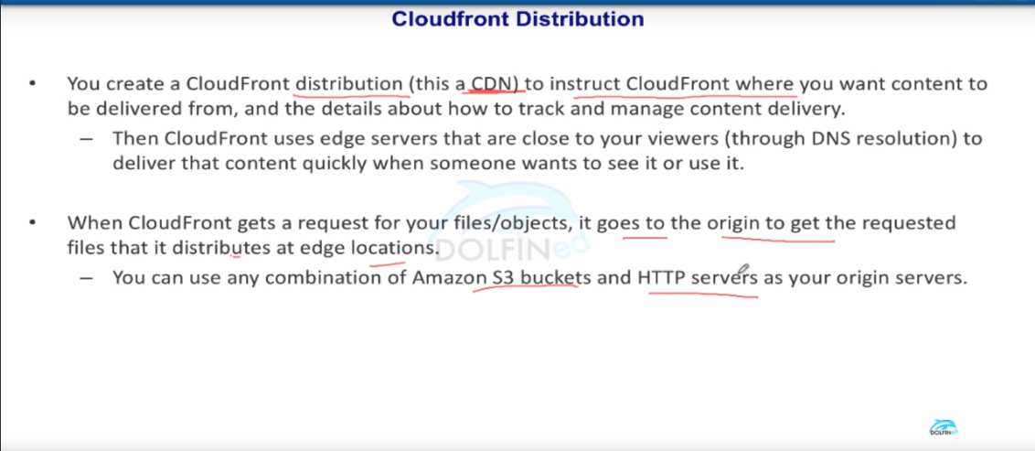

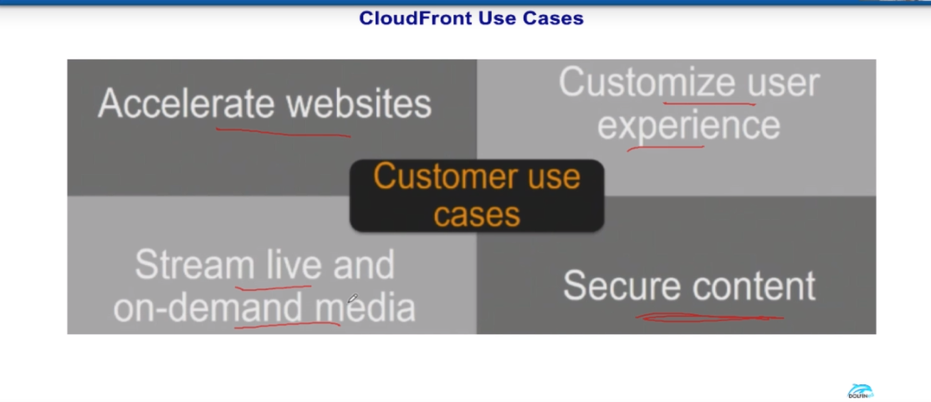

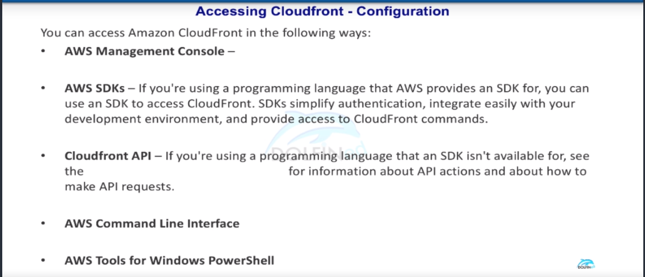

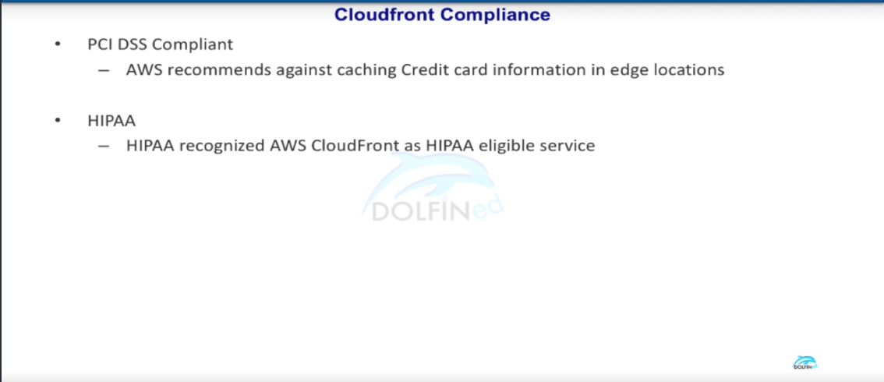

Lecture-248 CloudFront - Static and Dynamic Content

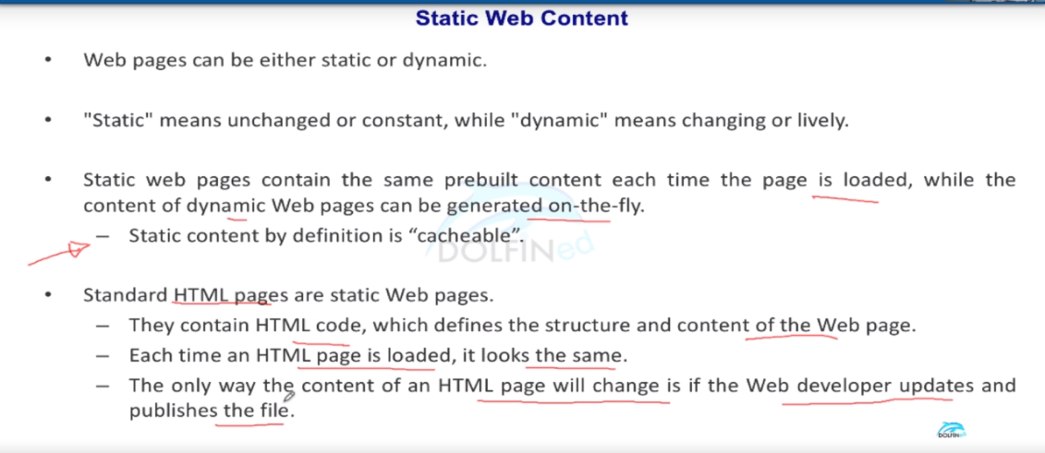

Cachebality of the static content is very high

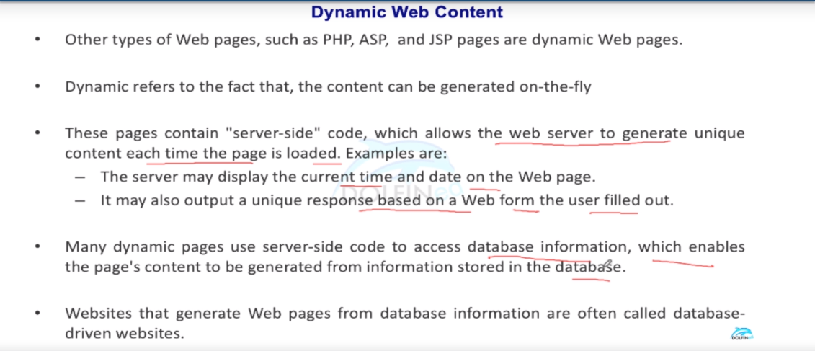

Depends on the how dynamic the web page is you can tell whether is it is cacheable or not cacheable or partially can be done

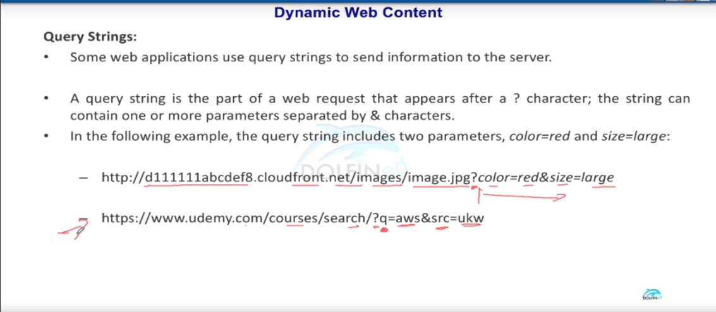

Lecture-250 CloudFront Regional Edge Cache

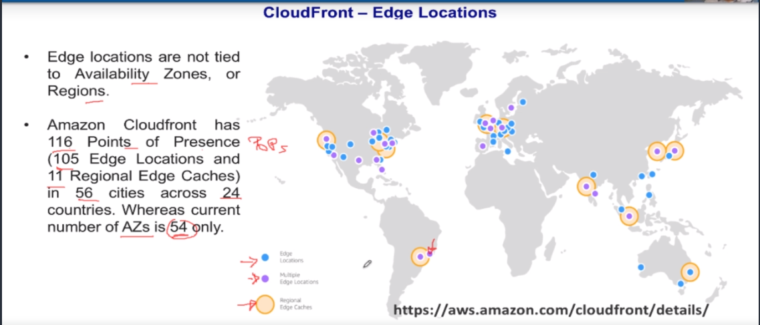

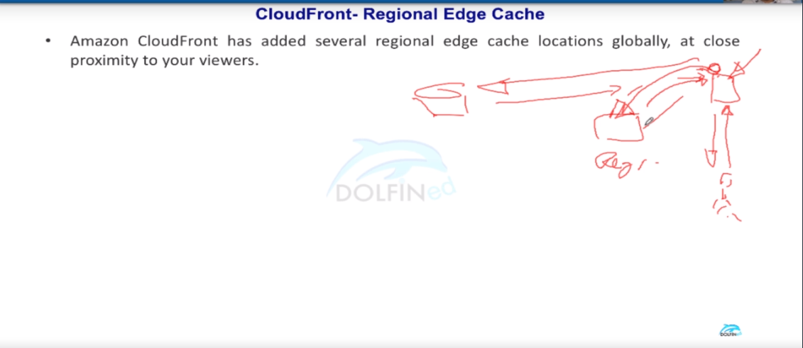

From the above picture the scenario as follows when there is an object (Small rounded) that does not accessed by users for a long time then the edge location will move the object cache to Regional Edge location (Reg written in fig) . So, if any user comes for accessing the object it will not go all the way origin to fetch it , It will search for it Regional cache location and the moved to edge location again then transferred to the user.

Other if the edge location cannot find it in Regional cache location the request will be send to the origin and it will be cached in both the location i.e., edge location & Regional edge location

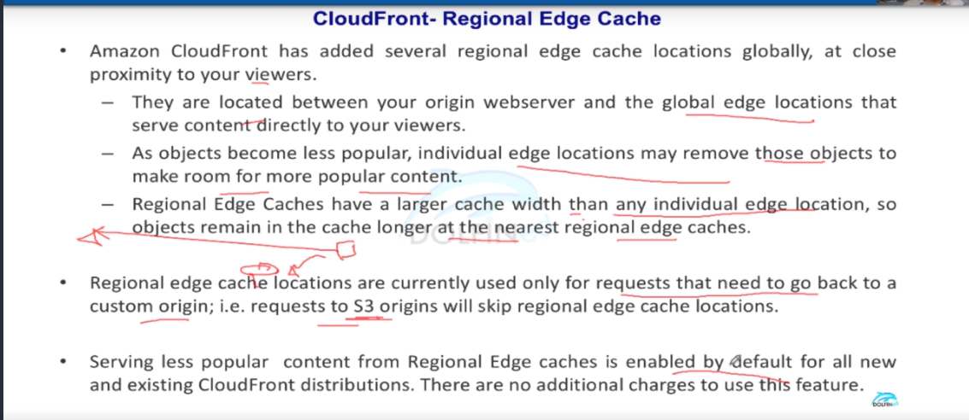

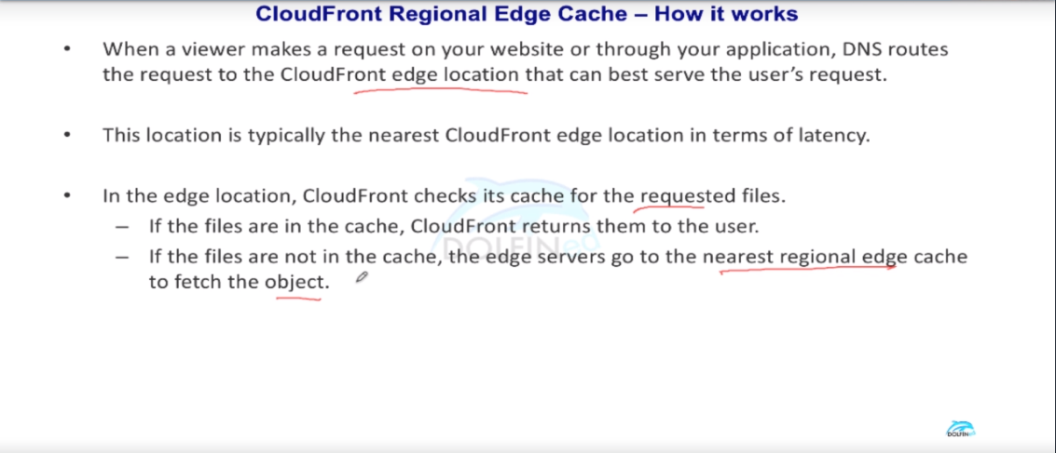

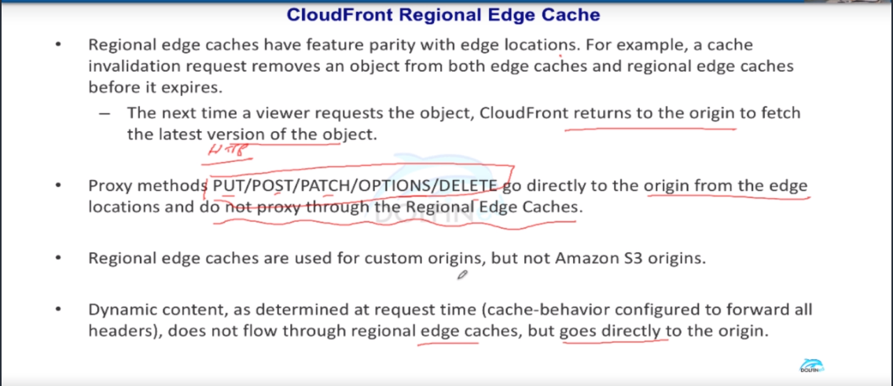

Imp Point : If you are maintaining the s3 static website hosting it is considered as custom origin but not s3 origin

Lecture-251 CloudFront Distributions

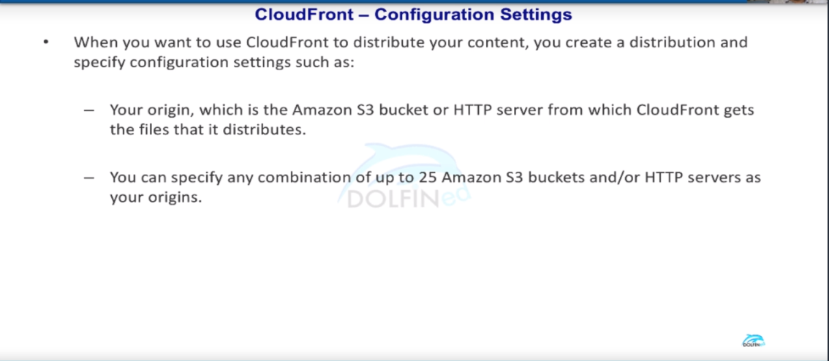

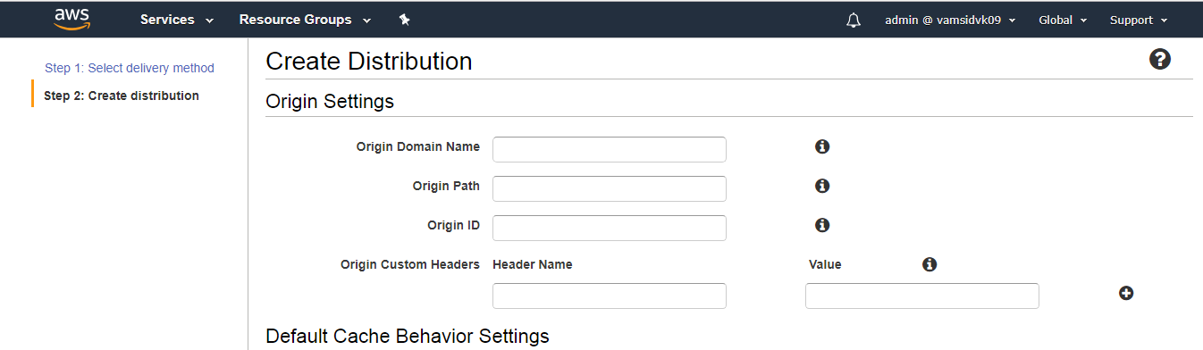

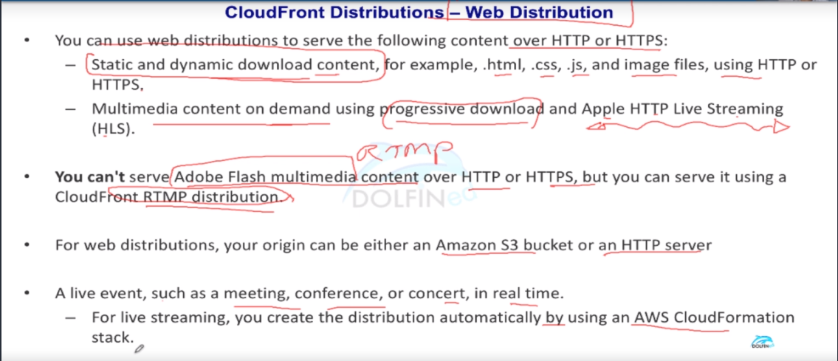

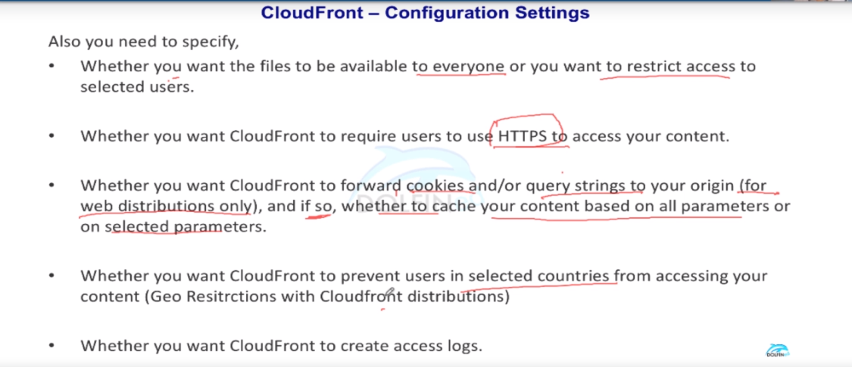

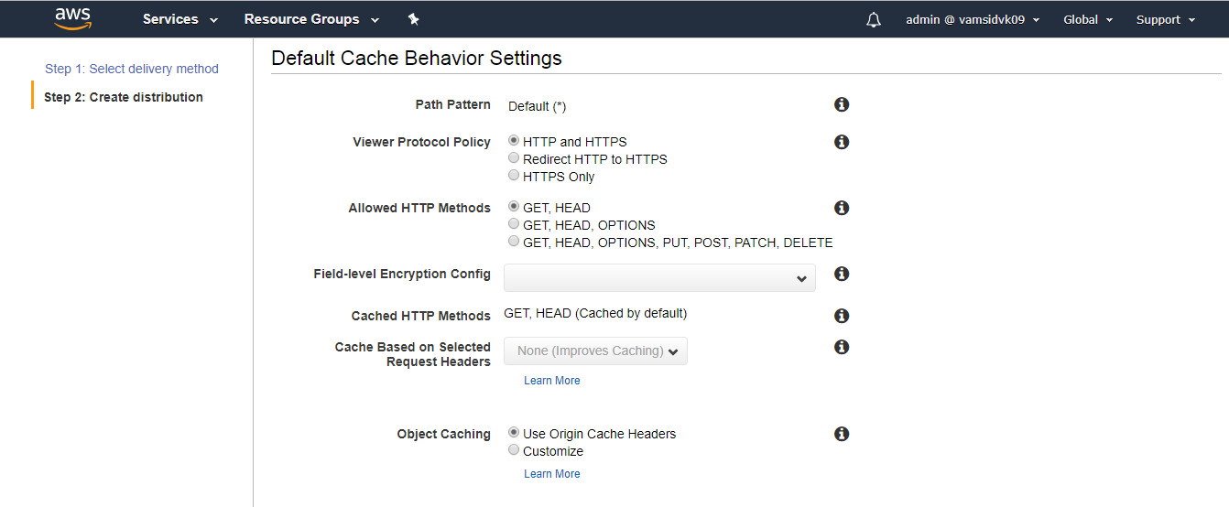

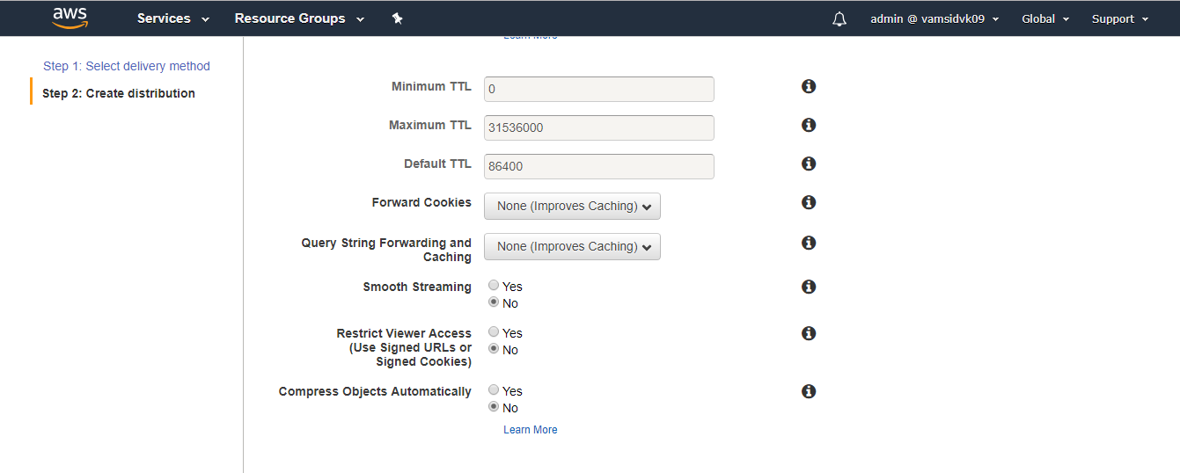

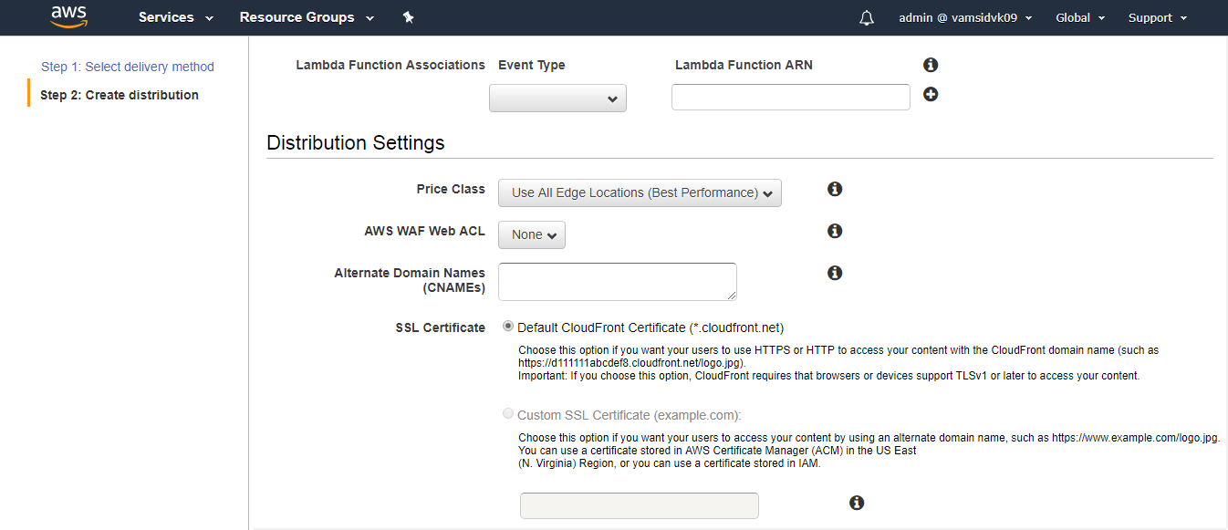

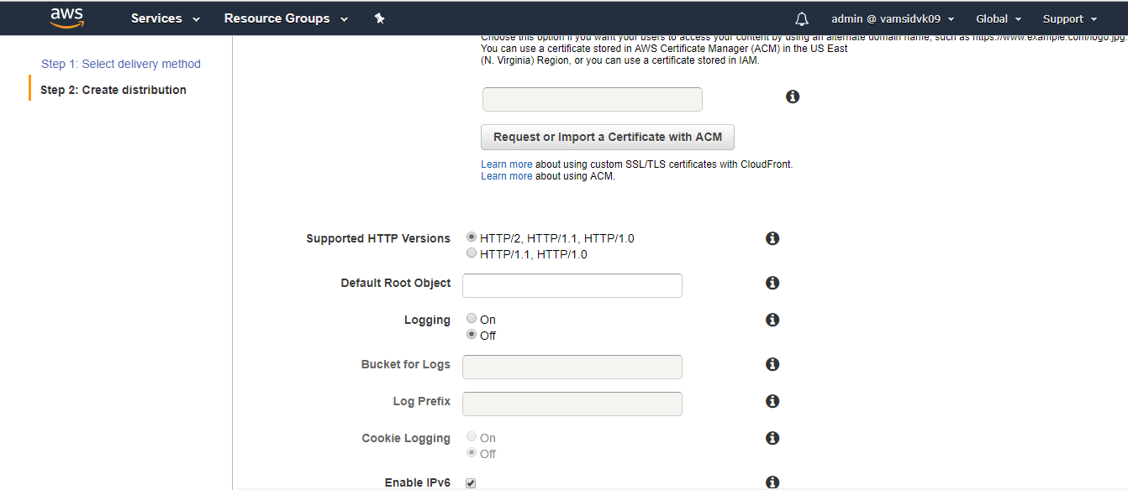

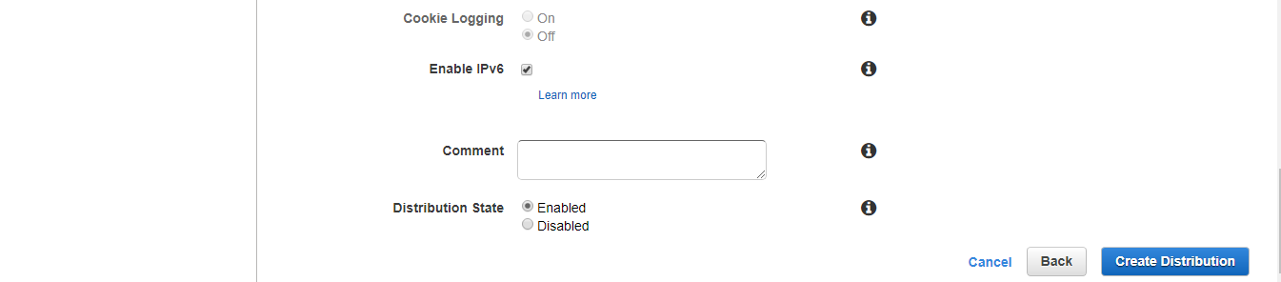

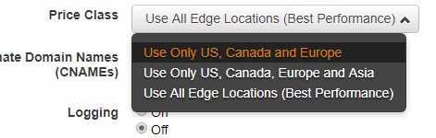

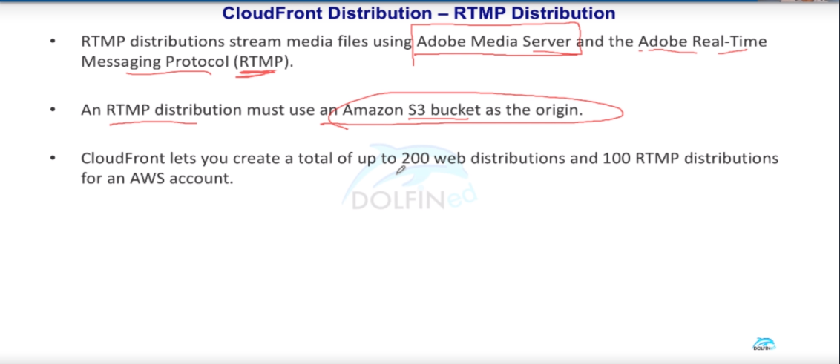

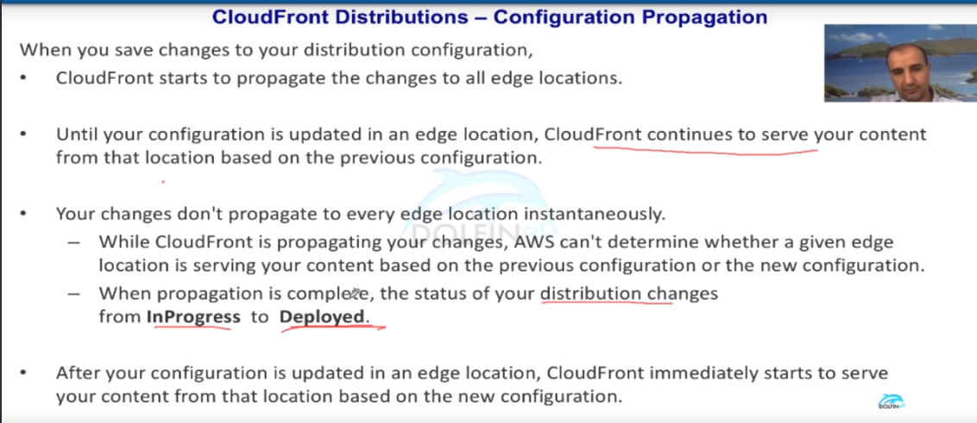

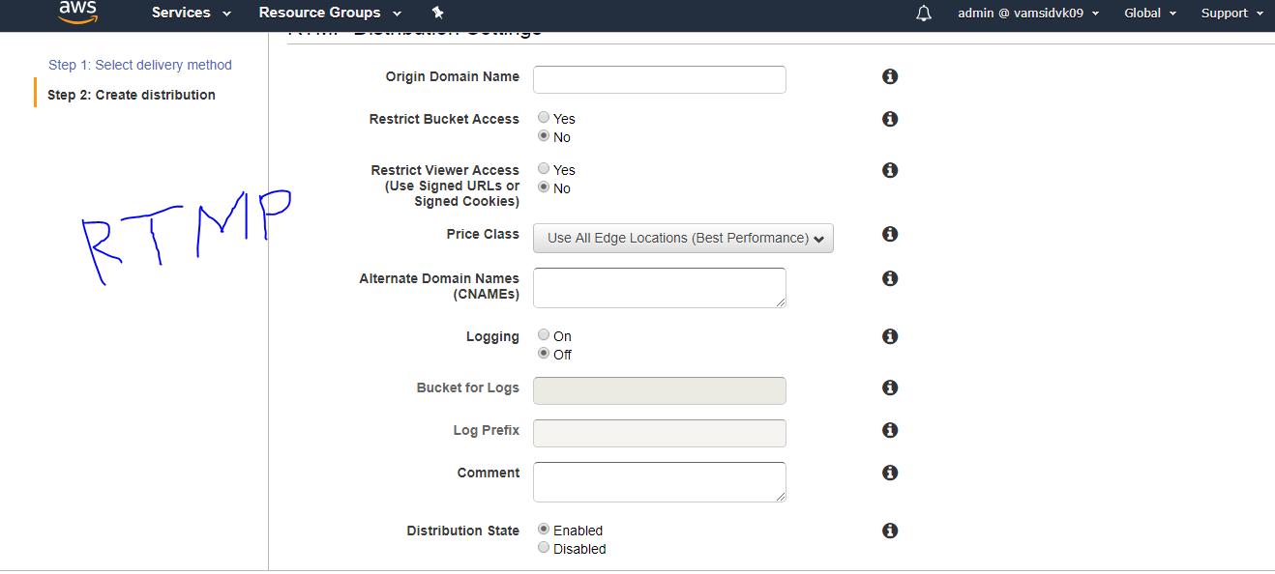

Lecture-252 CloudFront - Origin types

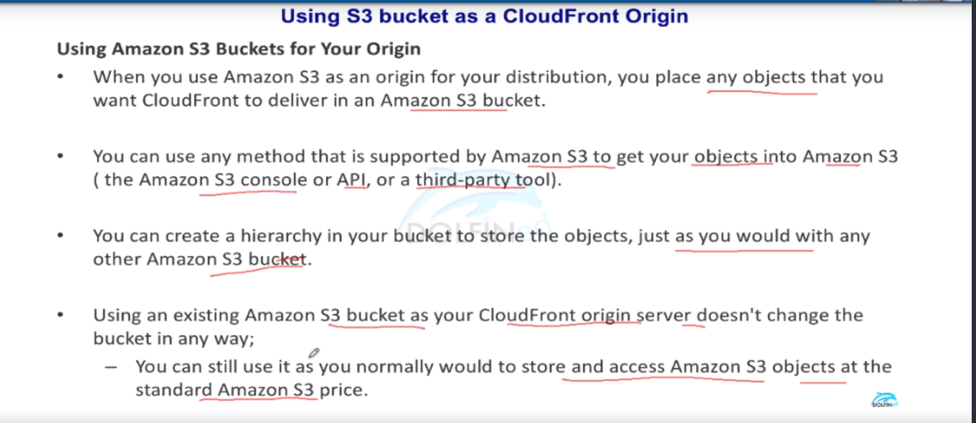

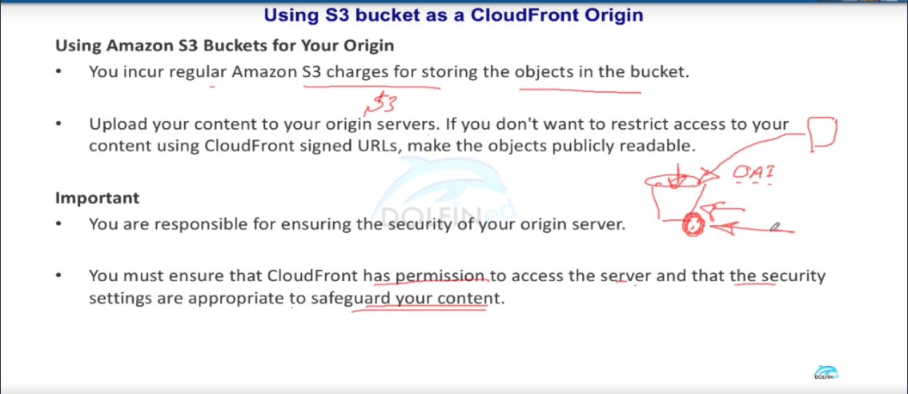

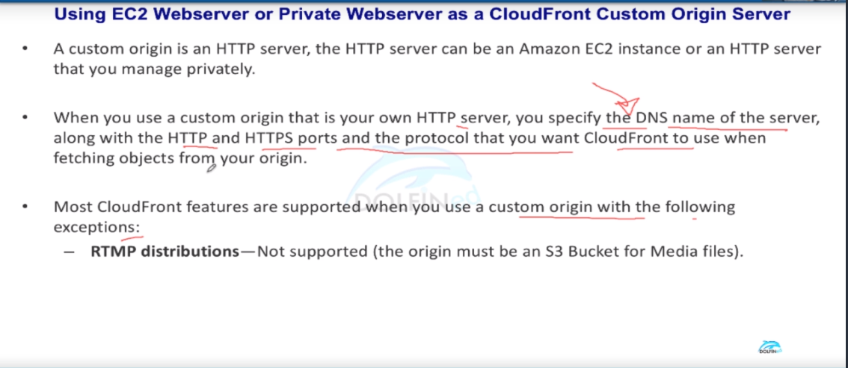

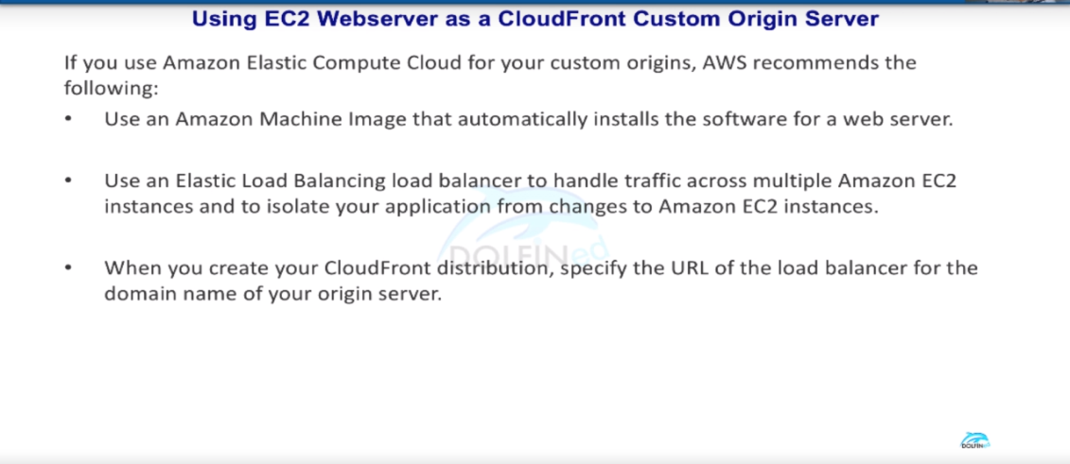

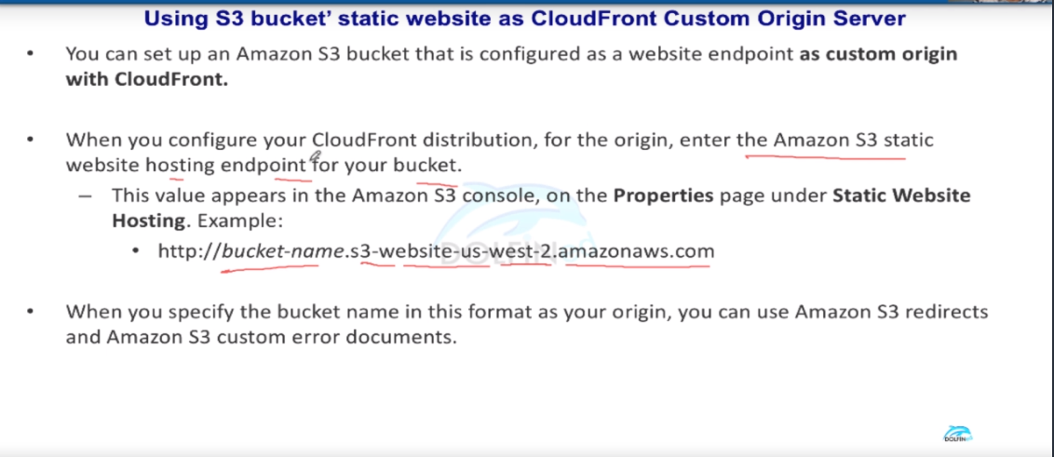

Lecture-253 CloudFront - Content Delivery

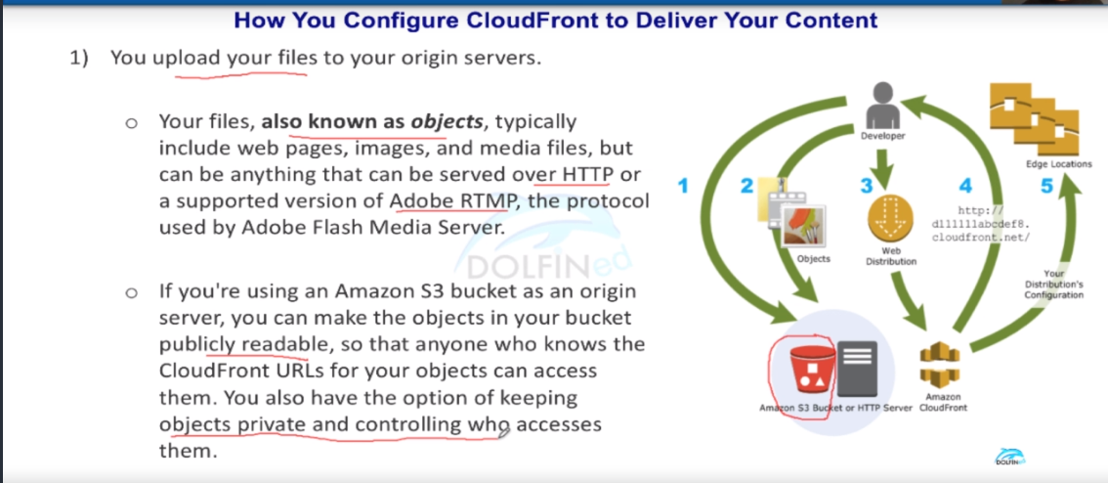

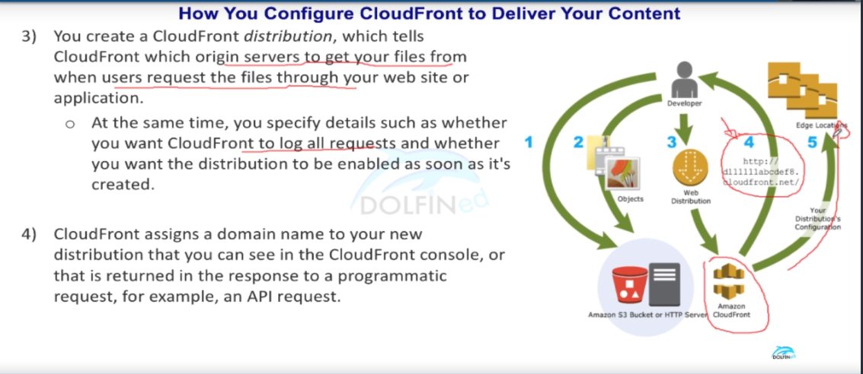

At the 4th arrow in the pic once cloudfront url is ready and when you paste in the browser add any content name such as images.html after the `/ ` then the cloudfront is ready .

And at 5th arrow the cloudfront distribution will be deployed on all the specified edge locations.

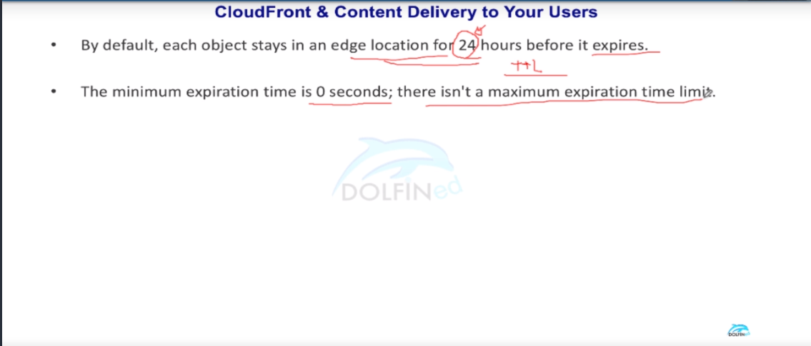

If you specify o seconds in the time limit it might state that user is using Content delivery network a.k.a cloud front for to safeguard against security attacks such as DDos attacks

Lecture – 254 CloudFront - Alternate Domain Names

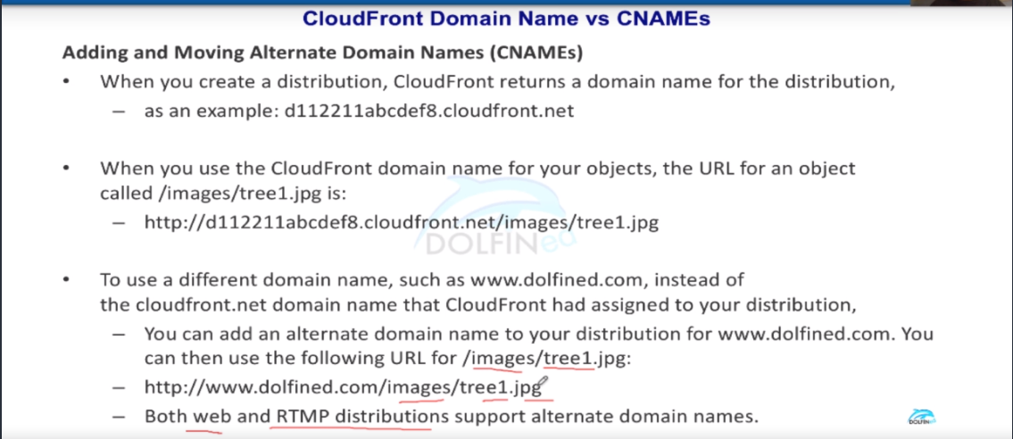

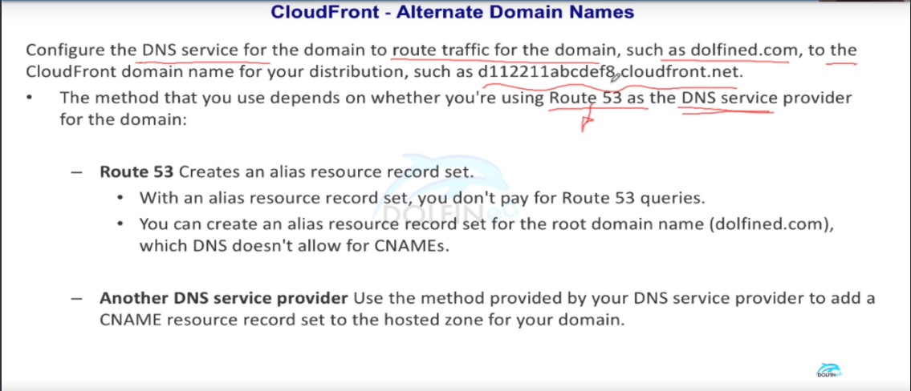

You can NOT configure a CNAME for the apex domain \*\*\* Imp point

